**A PROPOSAL ON A PROJECT TPIC**

**TITLED**

**‘*AUTOMATED ATTENDANCE TRACKING SYSTEM USING BLUETOOTH DEVICE IDENTIFICATION’***

**BY**

**GABRIEL, Ushie Osise**

**2019/1/78786CM**

**SUPPERVISED**

**BY**

**Main Supervisor**

**Dr. STEPHEN OWYEWOBI**

**Co-supervisor**

**Prof. ELIZABETH, N. ONWUKA**

**PRESENTED**

**TO**

**TELECOMMUNICATION ENGINEEING DEPARTMENT**

**FEDERAL UNIVERSITY OF TECHOLOGY**

**MINNA**

**MARCH, 2025**

**INTRODUCTION**

The Automated Attendance Tracking System using Bluetooth technology is a modern, contactless solution designed to streamline attendance management in educational and professional environments. Traditional methods such as manual roll calls and sign-in sheets are time-consuming, prone to errors, and inefficient for large groups. Existing digital solutions, while effective, often require expensive hardware or complex setups, making them inaccessible for many institutions.

This project leverages Bluetooth-enabled devices, such as smartphones, to automate attendance logging in real time. Using unique session identifiers and Bluetooth synchronization, students can seamlessly check in without disrupting class activities. The system ensures accuracy, reduces administrative workload, and enhances security by using encrypted data transmission.

**Problem Statement**

Current attendance tracking methods face several challenges, including inefficiency, human error, and scalability limitations. Manual processes are labor-intensive, while digital alternatives often involve high costs or privacy concerns. There is a need for a cost-effective, automated system that ensures accuracy, scalability, and real-time synchronization with a secure backend.

**Aims and Objectives**

This project aims to design and implement an automated Bluetooth-based attendance tracking system with the following objectives:

* Automate Attendance Logging: Detect and register attendance using Bluetooth synchronization.
* Enhance Accuracy & Efficiency: Eliminate manual errors and reduce administrative burden.
* Ensure Scalability: Support large groups with real-time processing.
* Improve Security & Privacy: Use encrypted communication and compliance measures.
* Provide an Intuitive Interface: Develop a user-friendly dashboard for managing attendance records.

**LITERATURE REVIEW**

Automated attendance tracking has advanced beyond manual roll calls, with RFID, biometric, and Bluetooth-based solutions emerging to improve efficiency and accuracy.

Azim et al. (2020) proposed a Bluetooth-enabled attendance system integrating RFID and microcontrollers. Students register using RFID tags, which are transmitted via Bluetooth to an Android application. While this reduces manual errors, reliance on RFID tags increases costs and complexity​.

Alrowaily (2022) developed a BLE beacon-based system where students’ mobile devices act as attendance broadcasters, allowing academic staff to verify attendance. This approach eliminates additional hardware but requires students to actively broadcast their presence, which may introduce inaccuracies or delays​.

This project builds on these approaches by introducing:

Session-Based Validation: Attendance is logged only during the class duration, reducing fraudulent check-ins.

Real-Time Synchronization: Direct updates to a cloud-based backend for instant access.

Improved Security & Privacy: Encrypted communication prevents unauthorized tracking.

Seamless Mobile Integration: Students automatically check in via Bluetooth without manual broadcasting.

By addressing these limitations, the proposed system enhances scalability, accuracy, and security, making attendance tracking more reliable and user-friendly.

**METHODOLOGY**

**System Overview**

The automated attendance system leverages an ESP32 microcontroller, Bluetooth scanning, and real-time backend synchronization to efficiently log student attendance. The system consists of:

ESP32 Module: Scans for Bluetooth devices and syncs attendance records.

OLED Display & Buttons: Allows instructors to input course codes and manage sessions.

Bluetooth Module: Detects nearby student devices for automatic check-in.

Mobile Application: Enables students to sync with the ESP32.

Cloud Backend (MongoDB/Firebase): Stores attendance data in real-time.

**Block Diagram**

wifi/internet

Management and monitoring software

Database

Bluetooth Module

Student Bluetooth device/cell phone

(labeled block diagram showing Bluetooth login device, Bluetooth, mobile app, and backend.)

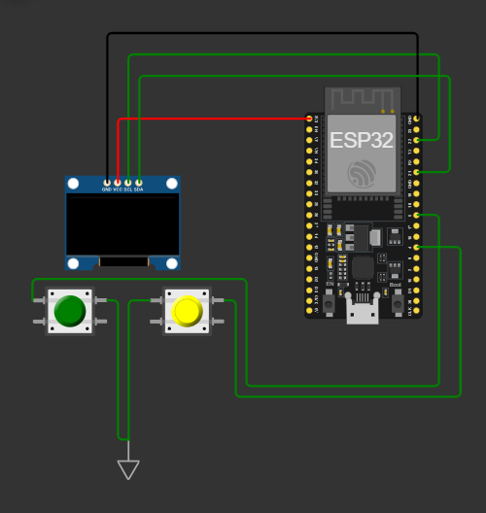

Circuit diagram of the Bluetooth attendance device

**Simulation & Testing environment**

The system is developed and tested using Wokwi for circuit simulation and Arduino IDE for coding. The ESP32 scans for Bluetooth devices and logs detected MAC addresses to the Serial Monitor and OLED display. Real-time data is sent to a cloud database via Wi-Fi.

This methodology ensures a low-cost, scalable, and efficient attendance tracking system with minimal hardware requirements.

**PRELIMINARY RESULTS**  
**Simulation Results,**

The simulation was successfully carried out of the device functioning. Changing and beginning the search for Bluetooth devices. But simulations have not been done relating to the mobile app and the dashboard considering the high complexity of doing so.

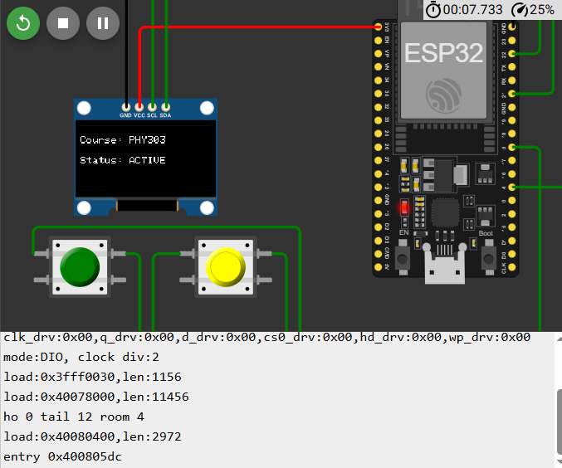

Image showing the simulation in process.

**Circuit Components & Wiring**

ESP32 Development Board (~₦12,500 – ₦18,500)

OLED Display (SSD1306, I2C) (~₦8000–₦12,000)

Push Buttons (x2) (~₦1500)

Resistors (10kΩ for pull-downs) (~₦500)

Power Supply (USB/Battery) (~₦8000)

Total Estimated Cost: ₦35,000–₦50,000 per unit

**REFERENCES**

[1] N. A. Azim, A. M. Hussein, H. I. Shawky, and H. A. Joudah, "Bluetooth Smart based Automated Attendance System," Int. J. Adv. Trends Comput. Sci. Eng., vol. 9, no. 3, pp. 4137-4140, 2020. doi: 10.30534/ijatcse/2020/242932020.

[2] M. A. Alrowaily, "Utilizing beacon technology for the development of a smart attendance system," Int. J. Adv. Appl. Sci., vol. 9, no. 6, pp. 26-35, 2022. doi: 10.21833/ijaas.2022.06.004.

[3] Espressif Systems, "ESP32 Technical Reference Manual." [Online]. Available: https://www.espressif.com/en/support/download/documents

[4] Arduino, "ESP32 with Arduino IDE – Programming and Basics." [Online]. Available: https://www.arduino.cc/en/Guide/ESP32

[5] Wokwi, "ESP32 Simulator for Prototyping and Development." [Online]. Available: https://wokwi.com/

[6] Firebase Documentation, "Real-time Database and Cloud Firestore." [Online]. Available: https://firebase.google.com/docs

[7] MongoDB, "Cloud Database and NoSQL Solutions." [Online]. Available: https://www.mongodb.com/docs